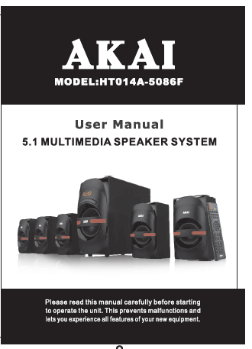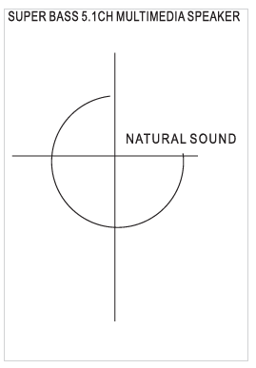

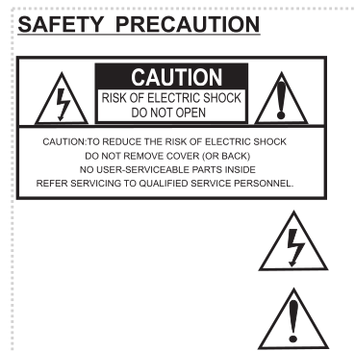
WARNING:
To prevent fire or shock hard, do not expose the unit to
rain or moisture.
*Note:This product is for indoor use only.
The lightning flash with arrowhead symbol, within an equilateral triangle, is intended to alert the user to the presence of uninsulated “dangerous voltage” within the product’s enclosure that may be of sufficient magnitude to constitute a risk of electric shock.
The exclamation point within an equilateral triangle is intended to alert the user to the presence of important operating and maintenance (servicing) instructions in the literature accompanying the product.

IMPORTANT SAFETY INSTRUCTIONS

- Read these instructions before using the product.
- Read all warnings carefully.
- Follow all instructions carefully.
- Do not use this apparatus near water.
- Clean only with dry cloth.
- Do not block any ventilation openings. Install in accordance with the manufacturer’s instructions.
- Do not install the speaker system near any heat sources such as radiators, heat registers, stoves, or other apparatus (including amplifiers) that produce heat.
- Protect the power cord from being waled on or pinched particularly at plug points and the point where they exit from the unit.
- Only use attachments/accessories specified by the manufacturer.
- Use only with the cart, stand, tripod, bracket, or table specified by the manufacturer or sold with the unit. When a cart is used, be cautious while moving the cart/unit combination to avoid injury from tip-over.
- Unplug this apparatus during lightning storms or when unused for long periods of time.
- Refer all servicing to qualified service personnel. Servicing is require when the unit has been damaged in any way, such as power-supply cord or plug is damaged, liquid has been spilled or objects have fallen into the unit, the unit has been exposed to rain or moisture, does not operate normally, or has been dropped.

DISPOSAL OF WASTE ELECTRICAL AND ELECTRONIC EQUIPMENT
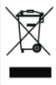
This symbol on the product or packaging means that the product should not be treated as household waste. Do not throw garbage at the end of its life, but take it to a collection center for recycling. In this way you will help to protect the environment and be able to prevent any negative consequences that it would have on the environment and human health.

To find your nearest collection center:
- Contact local authorities:
- Access the website:www.mmediu.ro;
- Request additional information from the store where you purchased the product.

PACKING LIST

1. Subwoofer : 1 unit
2. Satellite Speakers : 5 unit
3. Audio Cable : 3 unit
4. User Manual : 1 unit
5. Remote Control : 1 unit
6. Warranty Card : 1 unit

DESCRIPTION OF THE SUBWOOFER CONTROL PANEL
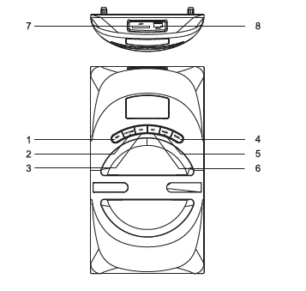

- INPUT
- Play/pause
- Previous
- Volume + adjustment
- Volume – adjustment
- NEXT
- SD/MMC input
- USB input

AC POWER
IMPORTANT NOTES
.Make sure the power supply is proper and never handle the power cord or its plug with wet hands when plugging into, or unplugging from an outlet.
.Ensure that the main power switch is in the “OFF” position before connecting the AC power cord to the power supply to avoid damage to the unit.
.A damaged power cord can easily cause an electric shock or fire hazard; Never use a power cord after it has been damaged.

BATTERY INSTALLATION
- Open the battery case.
- Insert two batteries without the polarity reversed.
- Close the battery case.
- Keep within 5 meter range, 30 degree angle while aiming at the unit.

Precautionary note:
Remove the battery when the unit is not being used for a long period of time.
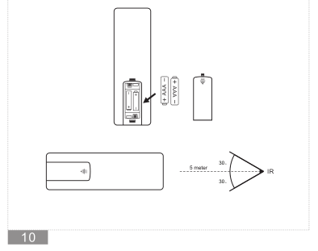

DESCRIPTION OF THE REMOTE CONTROL
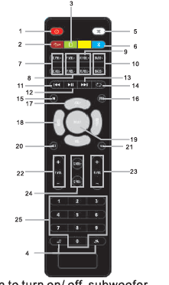

- STANDBY: To enter/exit standby mode
- USB: To enter into USB playback.
- SD/MMC: To enter into SD/MMC playback.
- EQ MODE/EQ OFF : To choose audio output sound field effect(POP, ROCK, JAZZ, CLASS, COUN)
- MUTE:To mute the sound
- BT: This button only functions when your speaker system has BT function
- CENTER+, - : To increase or reduce the Center Volume.
- FRONT+, - : To increase or reduce the Front Volume.
- REAR+, - : To increase or reduce the Rear Volume.
- BASS+, - : To increase or reduce the Bass Volume.
- PREV : To select the previous song in USB/SD/BT.
- PLAY/ PAUSE : To play/pause.
- NEXT : To select next song in USB/SD/BT
- REPEAT: To repeat an audio play
- M: Mode switchover (USB,SD, AC-3,AUX,BT)
- PRO : Logic channel switch
- VOL+,- : To increase volume
- BASS+,- : To increase the Bass volume
- RESET : Long press to recover to default mode
- AUX IN : To enter into Aux playback.
- 5.1 : To enter into 5.1ch input
- FRONT+,- : To increase or reduce the Front Volume.
- REAR+,- : To increase or reduce the Rear Volume.
- CENTER+, - : To increase or reduce the Center Volume.
- 1-0: To choose 1-0 Numerical play

SUBWOOFER REAR SIDE DESCRIPTION

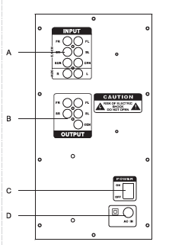
A. STEREO INPUT
RCA Connectors to take input from external audio source

B. AC 3 /5.1 OUTPUT
Front left, front right, rear left, rear right & center

C. POWER ON/OFF switch

D. POWER INPUT
AC220V 50Hz

UNIT OPERATION
- First plug the cable of satellite into the output jack on rear panel of woofer, one end of audio cable connected into the input jack on rear panel of woofer, the other end connected into the output jack of the computer or any external audio source.
- Connect the AC power cord with power socket to the main, press ON/OFF switch on the rear panel of subwoofer, LED indicator light up in red color, the units enters into AUX mode.
- Press “Volume + / Volume - ” button on woofer front panel or remote to adjust the volume in playback mode. Press “BASS+/BASS-” button on remote to adjust the bass.
- Press ”Prev / Next” button on woofer front panel or remote choose previous/next song in playback mode.
- Press ”Play/Pause” button on woofer front panel or remote to pause the music in playback mode.Press again to resume the music.
- When USB or SD card is playing, press “input” button to cycle through AUX/BT/USB/SD.
- After Stop using the unit, turn off the power switch, unplug the power cord.

BT Operating:
- Press “BT” on remote controller or “Input” button on subwoofer front panel, the units enters into BT playback, LED indicator of subwoofer front panel will flash in red color. Search for “HT014A-5086F” on BT device and pair the devices with the speaker system, the LED indicator of subwoofer front panel will keep lighting up in red color after connected successfully.
- When playing the files in BT devices, Short press “vol+/vol-” button on remote or subwoofer front panel to increase/decrease the volume; Short press “prev/next” button on remote or subwoofer front panel to select previous/next song in BT devices.

Note:BT working range is about 8 meter in open area.

FEATURES
→Analog audio input.
→Support USB, SD/MMC card music player in Mp3 file format.
→Full function remote control.
→Support BT connectivity.
→Volume control on the front panel, bass control on the remote.
→Built in 2 channel power amplifier.
→Compatible with MP3, MP4, PC, DVD, TV etc.

SPECIFICATIONS
Output Power:45W+12W×5
Frequency response: 40Hz~20KHz
Impedance: Subwoofer 8 Ohm, Satellite 4 Ohm
S/N Ratio:≥80dB
Isolation sensitivity:≥45dB
Distortion:≤0.3% at 1W output @1KHz
Speaker: 5.25’’+3’’
Power: AC220V 50Hz

