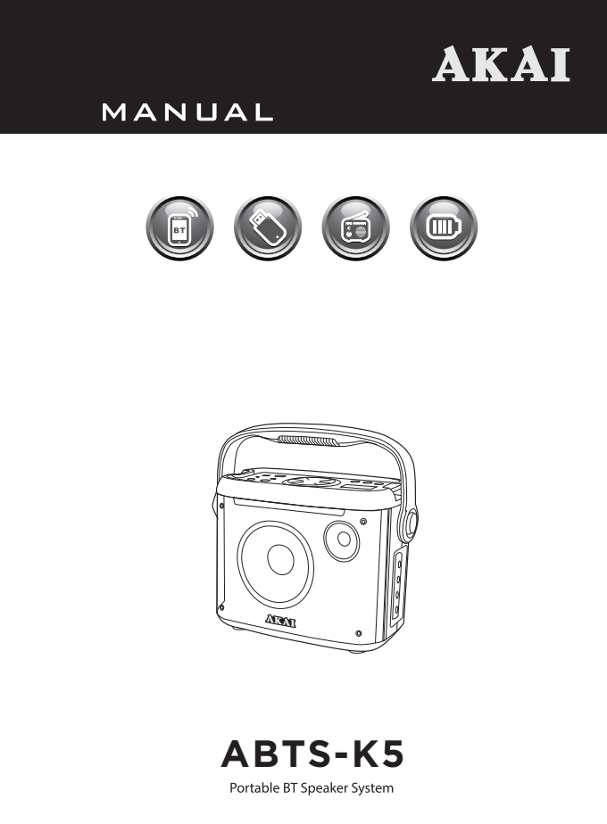

SaFETY PRECAUTIONS

Thank you for purchasing ABTS-K5:
This is your assurance of quality performance and value. Our engineers have included many useful and convenient features in this product. Please be sure to read this instruction Manual completely to make sure you are getting the maximum benefit from each feature.

This product was manufactured using the highest quality components and standards of workmanship.
It was tested by inspectors and found to be in perfect working order before it left our factory.

TO PREVENT FIRE OR SHOCK HAZARD DO NOT EXPOSE THIS APPLIANCE TO RAIN OR MOISTURE.
Notes: ━━━━━━━━━━━━━━━━━━━━━━━━━━━━━━━━━━━━━━━━━━━━━━━
- The images appearing in this manual are for reference only.
- Due to continual revision and improvement on our products design and specifications are subject to change without further notice.

CHARGEr AND BATTERY

BATTERY CHARGE INDICATOR

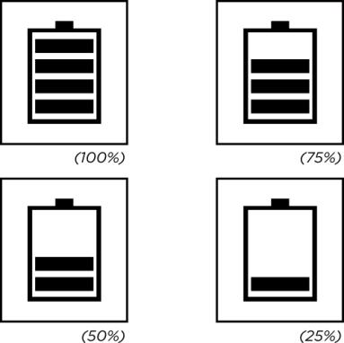
LED panel has battery status indicator. In the middle of
the shape of the battery has four horizontal lines, each
horizontal line represents 25% of electricity remaining.
When no horizontal line in the shape of the battery or
the shape flashes, please power of and promptly
charge to avoid damage to the battery.
When charging, the battery indicator on LED display
panel flashes.
The indicator stops blinking after full charged. Then
please continue to charge the battery for 1-2 hours to
extend the battery life.

WARNING!

If the battery is under voltage, please fully charge it within 48 hours.
If the speaker has to be left unused for a long time, please let the battery fully charged, otherwise it will cause damage to the battery.

TECHNICAL SPECIFICATION

MODEL ABTS-K5
Rated Power: ≤30W
Input sensitivity: 450±50mV
Battery: 7.4V 4000mAh
DC 5V IN: DC 5V
Charging time: 4-6h
Working time: 3-6h
Frequency response: 20Hz-20KHz
Audio S/N: ≥71dB
Bluetooth version: 5.0
Bluetooth channel emission power: 2dbm
Bluetooth frequency: 2.4 – 2.483GHz

DESCRIPTION OF REMOTE CONTROL


MUTE
Mute or restart the speaker.

INPUT (INPUT SELECTION)
Input selection (AUX input / Bluetooth / USB / FM function).

VOL+ (INCREASE VOLUME)

PLAY /PAUSE/SCAN

PREVIOUS

VOL-(DECREASE VOLUME)

NEXT

LED LIGHT CONTROL
Turn on the light / change the light mode.
Long press to turn off the light.

REPEAT
Repeat one, repeat all, repeat folder.

RECORD/PLAY RECORDING
Start recording, long press it to play the recordings.

PREVIOUS FOLDER
Change to the previous folder on USB input mode.

NEXT FOLDER
Change to the next folder on USB input mode.

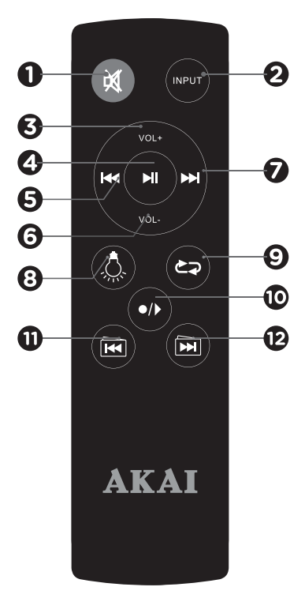





























DESCRIPTION OF CONTROLs
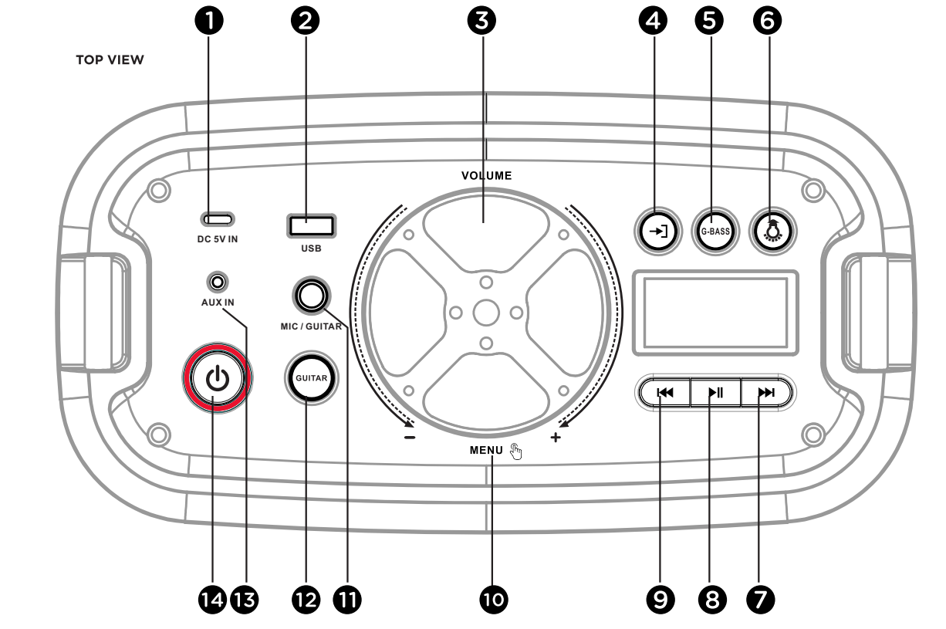


DC 5V IN
DC 5V charging interface (for adaptor).

USB PLAY SLOT

VOLUME

INPUT
With a short press on the button, select the input mode (AUX input / Bluetooth/ USB / FM radio)

G-BASS
Super good bass button.

LED LIGHT CONTROL
Short press to change the light mode.

NEXT 

PLAY / PAUSE / SCAN 

PREVIOUS

MENU
With a short press on the button, adjust treble /
bass / microphone volume / microphone echo /
guitar volume.

MIC / GUITAR SLOT
Use to connect the microphone / guitar jack.

GUITAR
Press to enter guitar mode.

AUX INPUT

POWER




MICROPHONE CONTROLS AND BASIC OPERATION
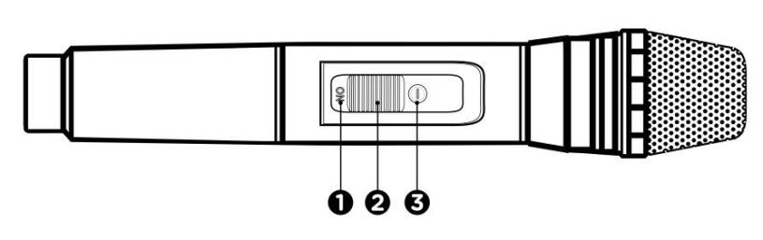
WIRELESS MICROPHONE

MICROPHONE ON/OFF
MUTE
LIGHT INDICATOR
Microphone frequency: 201.6 MHz
Channel emission power for wireless microphone: 50mW

FUNCTIONS
RECORDING FUNCTION FM FUNCTION

Choose INPUT to switch to FM RADIO.

Search and tune automatically to radio
stations by pressing on the remote control ro long press the button on the speaker.
Switch channels, by pressing and on the speaker or the remote control.
Press to record the voice into the external memory like USB disk on the speaker.

If the external memory is first time used, the system will automatically built a new folder named VOICE, and recording files in it will be named REC001, REC002, and so on.

In record mode, press / INPUT to stop recording.

Long press“ “ to play the recordings in the external memory, press PREV and NEXT to choose the recordings to play.

AWS FUNCTION (AKAI WIRELESS STEREO)
- Select the Bluetooth mode on the 2 speakers you wish to pair.
2、The 2 speakers need to be exactly the same in order to pair under AWS mode.
3、Select any one of the speakers and long press the "NEXT" button.
4、 A sound will be heard and the main speaker display will indicate "HOST" confirming that the 2 speakers are now paired.
5、The speaker display should indicate "BT".
6、To disconnect the AWS function, simply press the "PREVIOUS" button on the main speaker.
7、The speaker display should indicate "BT" in a flashing mode.
8、Long press the button to completely disconnect the Bluetooth connection with your mobile
device.

BLUETOOTH OPERATION
IMPORTANT:
Prior to use Bluetooth function, your speaker should be paired firstly with your Bluetooth device.
(“Paring” means establish connection between Bluetooth devices such as MOBILE PHONE, TABLETS,
PC, ETC).
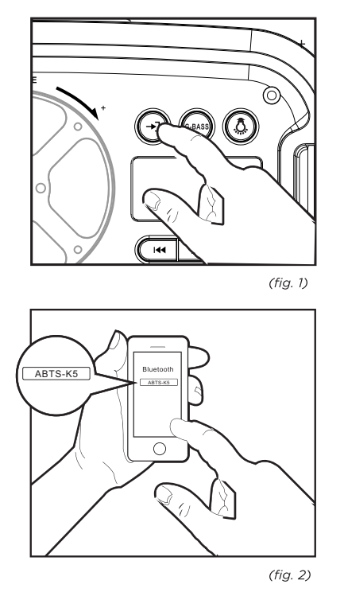
- Press the BT MODE button to switch into
the BT MODE (Bluetooth mode).
(fig.1)

- In BT MODE, a sound indication will
announce that Bluetooth pairing
mode is ready.
Then the micro system will search
automatically for Bluetooth devices.

- Turn on Bluetooth functionality on
your device and make it discoverable
(See your devices instructions to add
or setup a Bluetooth device).
- Search for Bluetooth equipment:
ABTS-K5 is your speaker identification.
(fig.2)
A sound indication will announce that Bluetooth
devices are successfully paired. (During the pairing,
if a password is required, you need to input code “0000”).
Your Bluetooth device stores the speaker unique identification at the same time.

ACCESSORIES

- 1 Charging cable
- 1 remote control
- 1 wireless microphone

TROUBLE SHOOTING GUIDE

If a fault occurs, first check the points listed below before taking the speaker to repair.
Do not open the speaker as there is risk of electric shock.
If you are unable to remedy a problem by following these hints, consult your dealer or service center.

SYMPTOM |  | CAUSE |  | CORRECTION
Sound
No sound | No input sound source. |  | Use a better music signal.
No sound | Volume is too low. |  | Adjust volume.
Distortion of sound | Volume too high. |  | Turn down the volume.
Distortion of sound | Speaker may be damaged. |  | If speaker is damaged, repair or replace it.
Karaoke
Karaoke does not work | Microphone plug is not fully inserted. |  | Plug microphone properly into the socket.
Karaoke does not work | Microphone switch is not on. |  | Turn on microphone switch.
Karaoke does not work | Microphone volume knob is at the lowest position. |  | Adjust microphone volume properly.
Karaoke does not work | Wireless microphone has low battery. |  | Replace battery.
MP3
MP3 does not play | The song format in the USB disc is incorrect. |  | Transform song format into MP3 format.
MP3 does not play | Improper operation has caused a process disorder. |  | Reboot the machine.
MP3 does not play | USB disk is disconnected. |  | Insert USB disc properly.
Remote control
The remote control does not work properly | The remote control is too far from the unit. |  | Operate the remote control within about 6m.
The remote control does not work properly | There is an obstacle in the path of the remote control and the unit. |  | Remote the obstacle.
The remote control does not work properly | The battery in the remote control is exhausted. |  | Replace the battery with new one.

WARNING!

Under no circumstances should you try to repair the set yourself, as this will invalidate the warranty.

DISPOSAL OF ELECTRICAL AND ELECTRONIC EQUIPMENT


This symbol on the product or packaging means that the product should not be treated as household waste. Do not throw garbage at the end of its life, but take it to a collection center for recycling. in this way you will help to protect the environment and be able to prevent any negative consequences that it would have on the environment and human health.

To find your nearest collection center:
- Contact local authorities
- Access the website: www.mmediu.ro

Request additional information from the store where you purchased the product.

IMPORTATOR: INTERVISION TRADING-RO SRL
Bld. I.C Bratianu, nr. 48-52, corp A, etaj. 5,
camera 504-505, oras Pitesti, judet Arges, Romania
Cod postal: 110121



