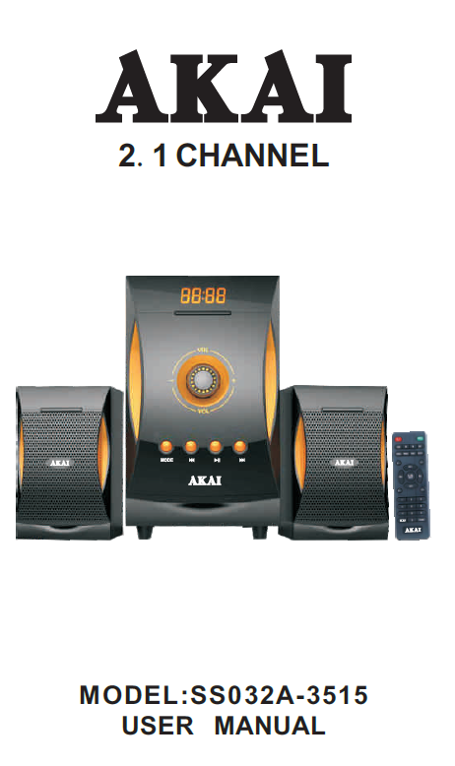
MULTIMEDIA SPEAKER SYSTEM
EN - ENGLISH
REMOTE CONTROL
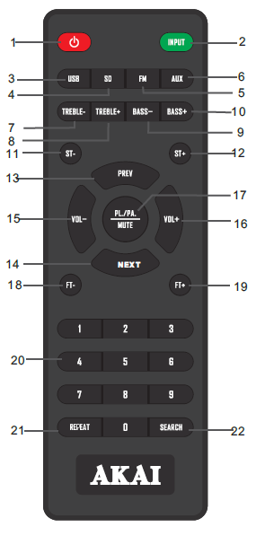 | - STANDBY: Press this button to Turn On/Turn Off the Set.  - INPUT: Press this button to select Input (Aux/FM/BT/USB/SD).  - USB: USB Audio Play.  - SD: SD Audio Play.  - FM: Play FM Station.  - AUX IN: AUX Audio Input.  - TREBLE (-): To reduce treble of the sound.  - TREBLE (+): To increase treble of the sound.  - BASS(-): To decrease the bass in the sound.  - BASS (+): To increase the bass in the sound.  - ST(-): To go to Previous FM Station.  - ST(+): To go to Next FM Station.  - PREV: In USB/SD Mode – to play previous song. In FM Mode – to go to previous radio station.  - NEXT: In USB/SD Mode – to play next song. In FM Mode – to go to Next radio Station.  - VOL(-) To decrease the master volume.  - VOL(+) To increase the master volume.  - PL/PA/MUTE: To operate function of Play/Pause or to Mute the sound.  - FT(-): FM Tuning Decreases by 0.1 MHZ by each Press.  - FT(+): FM Tuning Increases by 0.1MHZ by each Press.  - 0-9: to choose the song number in USB/SD Mode.  - REPEAT FUNCTION  ONE: Repeat current song.  ALL: Repeat all songs.  SHUF: Shuffle the songs and play again and again.  OFF: Play every song once, use their order.  - SEARCH: FM Station Auto Scan only.

REMARK
- Do not expose the apparatus to high temperature, water, moisture.
- Do not attempt to disassemble the product to avoid electric shock; only professionals should perform service.
- Please turn off the power and pull out the plug when you don’t use this product.
CONTROL PANEL DIAGRAM
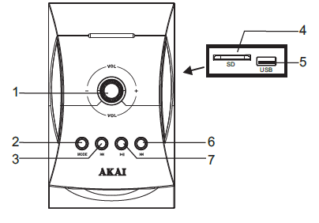 | - Volume/Mode adjustment  - MODE  - Last Music/FM scan  - SD Card Slot  - USB input  - NEXT Music/FM scan  - Play/Pause

SPEAKERS |  |  |  | AMPLIFIERS
 | SATELLITE SPEAKER | SUBWOOFER |  | Channel Separation | 45 db
Driver Size | 3 inch | 5.25 inch |  | Signal to Noise Ratio | 68 db
Impedance | 4 Ω | 4 Ω |  | Power Requirements
Frequency Range | 35Hz-20KHz |  |  | Voltage  Frequency | 220-230V~  50Hz

BACK PANEL CONNECTION DIAGRAM
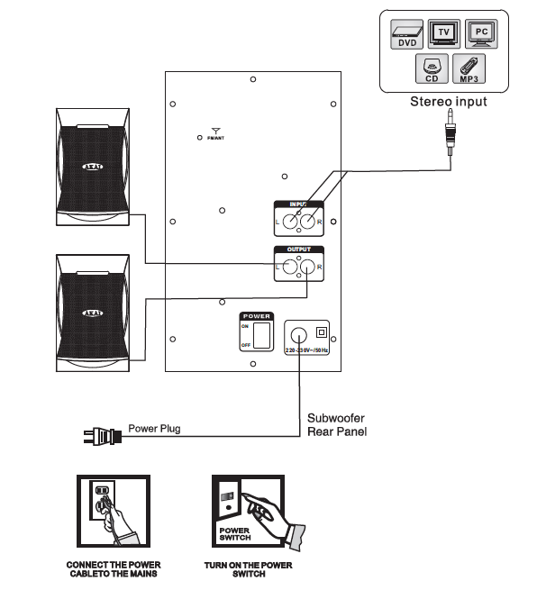
DISPOSAL OF ELECTRICAL AND ELECTRONIC EQUIPMENT
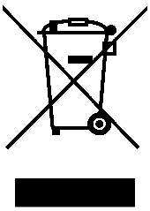
This symbol on the product or packaging means that the product should not be treated as household waste. Do not throw garbage at the end of its life, but take it to a collection center for recycling. in this way you will help to protect the environment and be able to prevent any negative consequences that it would have on the environment and human health.
To find your nearest collection center:
-Contact local authorities
- Access the website: www.mmediu.ro
Request additional information from the store where you purchased the product.

